Name: _____________________ Date: ____________
Revising Checklist
- I have a strong lead, that grabs the reader’s attention
- I used transition words (First, next, then, last) when appropriate
- I avoided unclear nouns like STUFF or THING and used more specific nouns
- I described all aspects of my setting including:
  - Where my story takes place
  - When my story takes place
  - What it looks like
  - What it sounds like
  - What it feels like
  - What it smells/tastes like (if possible)
- I described all of my characters in great detail
- My story has a beginning where a problem is introduced
- My story has a middle where characters work to solve a problem
- My story has an end where the problem is resolved
- I added any extra things my teacher asked
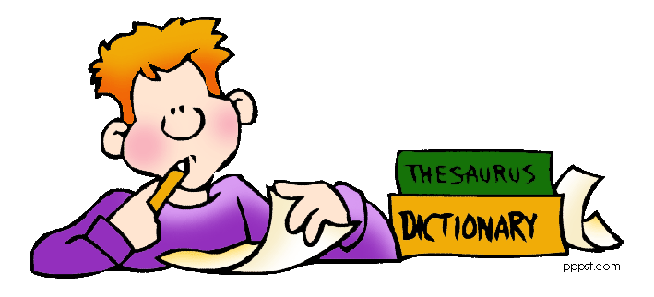
Mike Curry 2013

